**Jig Order Monitoring System**

**Work Instruction**

**TABLE OF CONTENTS**

**JIG ORDER MONITORING PROCESS FLOW** **4**

**MPPD1 / REQUEST INTERFACE** **5**

1. **LOGIN**
2. **IMPORT REQUEST DATA**
3. **REQUEST MONITORING**
4. **CANCELLATION REQUEST**
5. **ACCOUNT MANAGEMENT**
6. **LOGOUT**

**AME3 / PURCHASING INTERFACE** **10**

1. **LOGIN**
2. **UPDATE KIGYO BUDGET**

**AME2 / INSTALLATION INTERFACE** **15**

1. **LOGIN**
2. **DEDUCTION APPROVAL**
3. **UPDATE MASTER MAINTENANCE**
4. **UPDATE MANAGE ACCOUNT**

**USER ACCOUNT** **21**

1. **LOGIN**
2. **DEDUCTION BUDGET**
3. **EXPORT AND PRINT DEDUCTION SUMMARY**

**PROCUREMENT ACCOUNT** **27**

1. **LOGIN**
2. **UPDATE PURCHASE ORDER NO.**
3. **CANCEL PURCHASE ORDER**

**APPROVER ACCOUNT** **32**

1. **LOGIN**
2. **CANCEL PURCHASE ORDER**

**JIG ORDER MONITORING SYSTEM**

**PROCESS FLOW**

Log in to Jig Order Monitoring System

AME1 Import pending request data

Notify AME3 for the pending request

Export pending request and import Initial RFQ, RFQ, and PO process

View the closed request data history for a specific date

AME2 install and generate request based on installation date

AME1 monitor the delayed request Data

**JIG ORDER MONITORING SYSTEM**

**Work Instruction**

(**JOMS MPPD1**: PRODUCTION ENGINEERING)

1. **LOGIN**
   1. Enter **Username and Password** *(See Figure 1.0).*
   2. Click **Sign In** Button to access Main Form *(See Figure 1.0).*

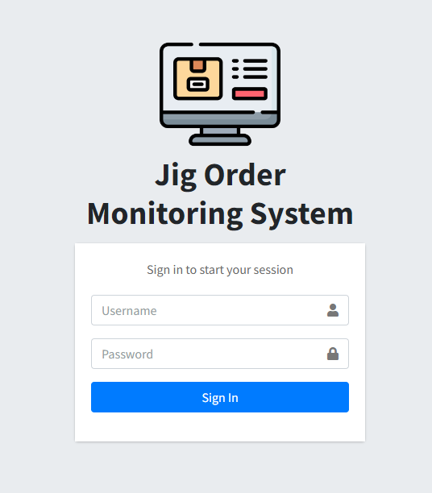

***Figure 1.0***

1. **IMPORT REQUEST DATA**

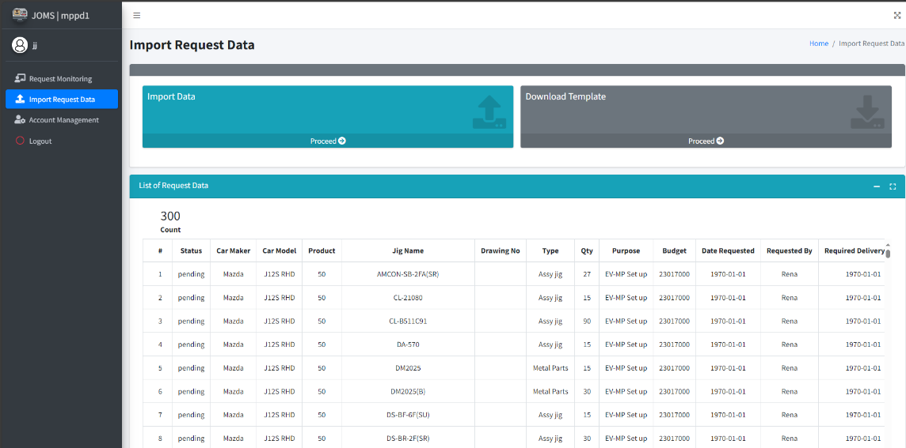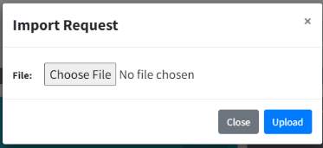

***Figure 1.1***

* 1. In the navigation bar, click **Import Request Data** (*See Figure 1.1*).
  2. Theuser can **download the template** by clicking the **Proceed** button as shown in the figure above (*See Figure 1.1*).

2.2. Open **template for request.csv** and encode the request data then **save the file**. (*See Figure 1.2*).

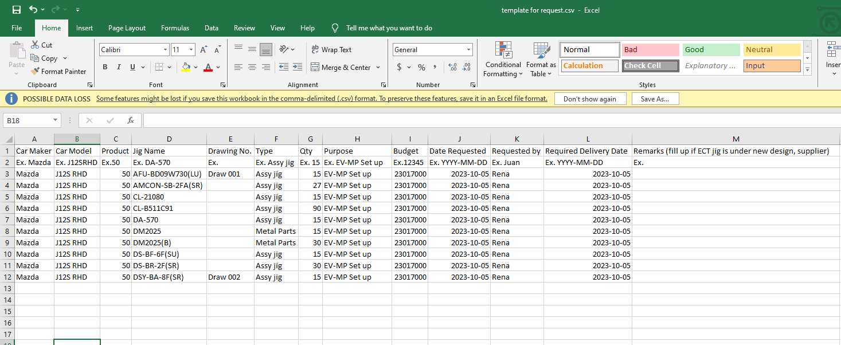

***Figure 1.2***

* 1. Click **proceed** in Import data then show the “choose file” (*See Figure 1.1*).

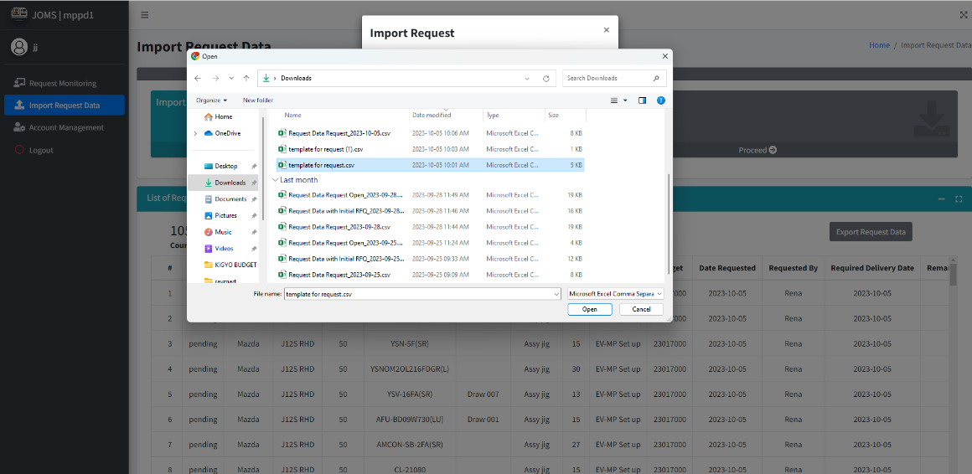

***Figure 1.3***

* 1. **Import** the data using the download template with encoded request data. Note that incorrect format will result to error (*See Figure 1.3*).

1. **REQUEST MONITORING**

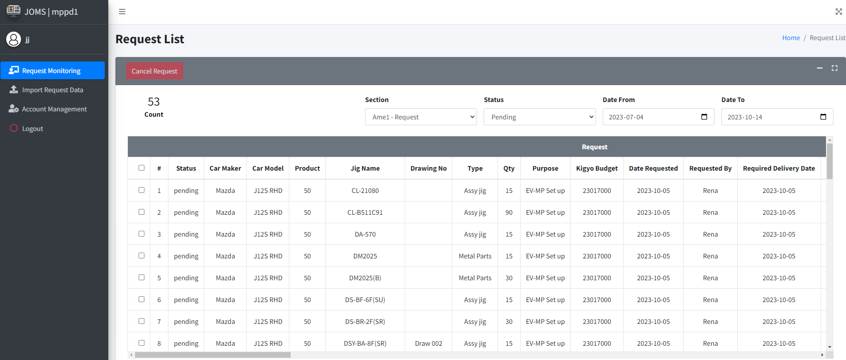

***Figure 1.4***

1. In the navigation bar, click **Request Monitoring** (*See Figure 1.4*).
2. To filter the table, click **Section, Status, Date From, Date to.** (*See Figure 1.4*).
3. Viewing the **number of rows** in the table. (*See Figure 1.4*).
4. **CANCELLATION REQUEST**

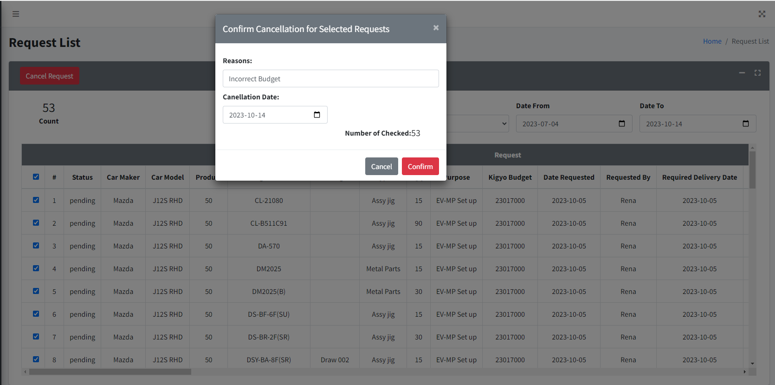

***Figure 1.5***

1. To cancel, select the **checkbox** that corresponds to the item you wish to cancel (*See Figure 1.5*).
2. Click the **Cancel Request** to pop up the **Cancellation for Selected Request.** (*See Figure 1.5*).
3. Provide an **explanation** for canceling and include the **date of cancellation,** click the **confirm** button. (*See Figure 1.5*).

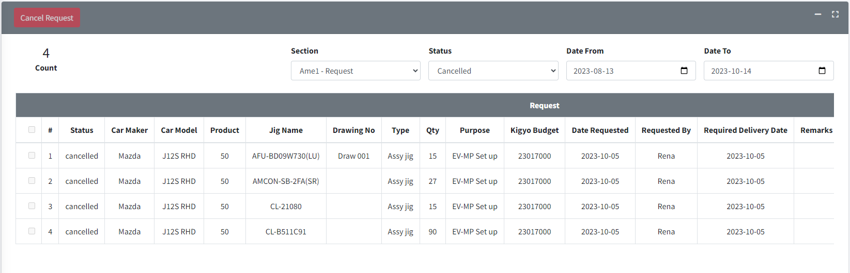

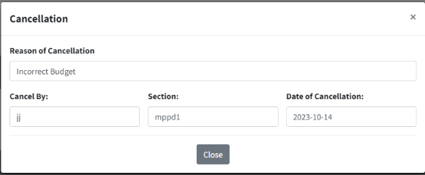

***Figure 1.6***

1. Click your **Section**, status must be **Cancelled,** and set the date from and date to. (*See Figure 1.6*).
2. Click **cancelled** under status column. (*See Figure 1.6*).
3. View the **cancellation** data. (*See Figure 1.6*).
4. **ACCOUNT MANAGEMENT**

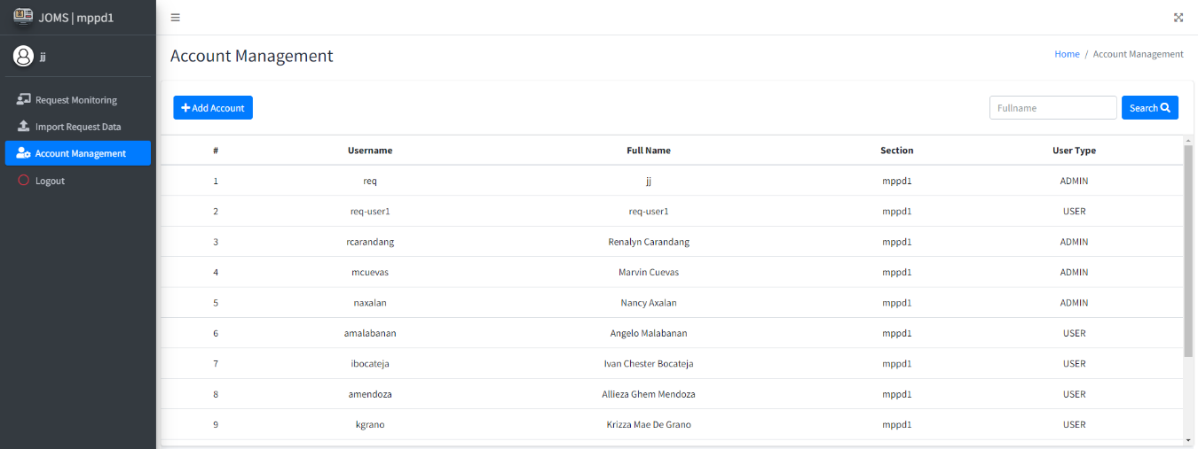

***Figure 1.7***

1. Click the **Account Management** (*See Figure 1.7*).
2. Click **Add Account** and create an account (*See Figure 1.7*).
3. **View** data table for your accounts. To Update, **Click** the data you want to **UPDATE**, or **DELETE** the account (*See Figure 1.7*).
4. **Search** accounts by full name (*See Figure 1.7*).
5. **LOG OUT**

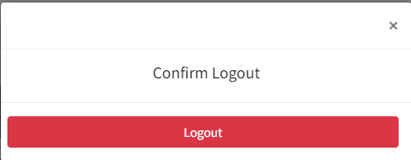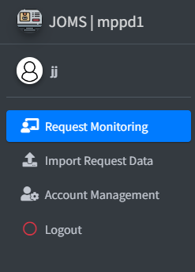

***Figure 1.8***

1. Click **log out**
2. Show msg box click confirm **Logout.** Don’t forget to log out when you’re not around or before leaving.

**JIG ORDER MONITORING SYSTEM**

**Work Instruction**

(**JOMS AME3**: PRODUCTION ENGINEERING)

1. **LOGIN**
   1. Enter **Username and Password** *(See Figure 1.0).*
   2. Click **Sign In** button to access Main Form *(See Figure 1.0).*



***Figure 1.9***

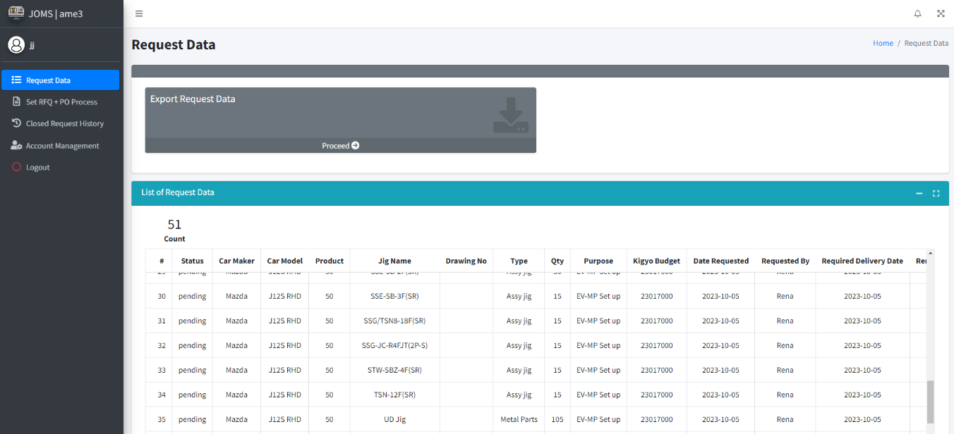

***Figure 1.4***

1. **UPDATE MASTER MAINTENACE**
   1. Click **FILE** and Select **MASTER MAINTENANCE** *(See Figure 1.5).*

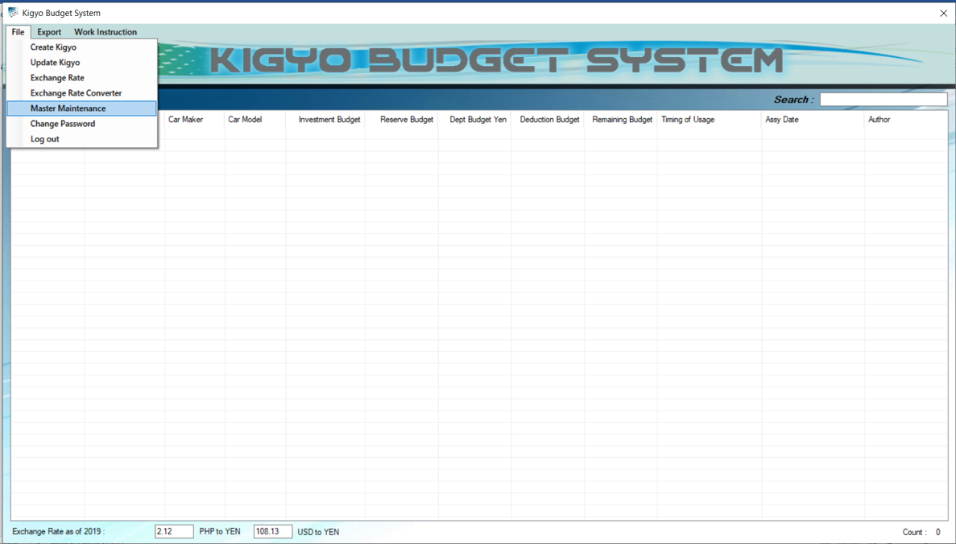

***Figure 1.5***

* 1. Select **MASTER MENU** *(See Figure 1.6).*
  2. 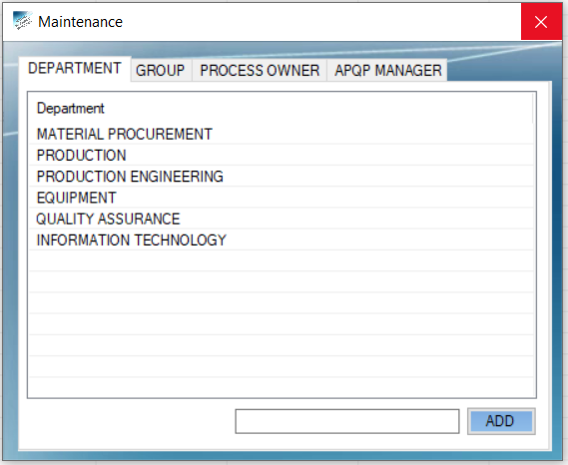Enter **NEW DATA** and Click ADD Button *(See Figure 1.6)*.

***Figure 1.6***

**KIGYO BUDGET SYSTEM**

**Work Instruction**

(**PROCESS OWNER**: STAFF & ABOVE)

1. **LOGIN**
   1. Enter **Username and Password** *(See Figure 1.7).*
   2. Click **Login** Button to access Main Form *(See Figure 1.7).*

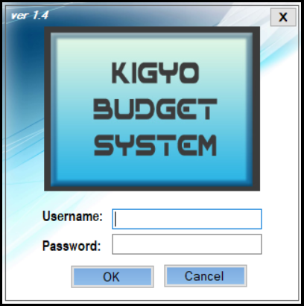

***Figure 1.7***

1. **UPDATE KIGYO BUDGET** 
   1. Click **FILE** select **UPDATE KIGYO** *(See Figure 1.8).*

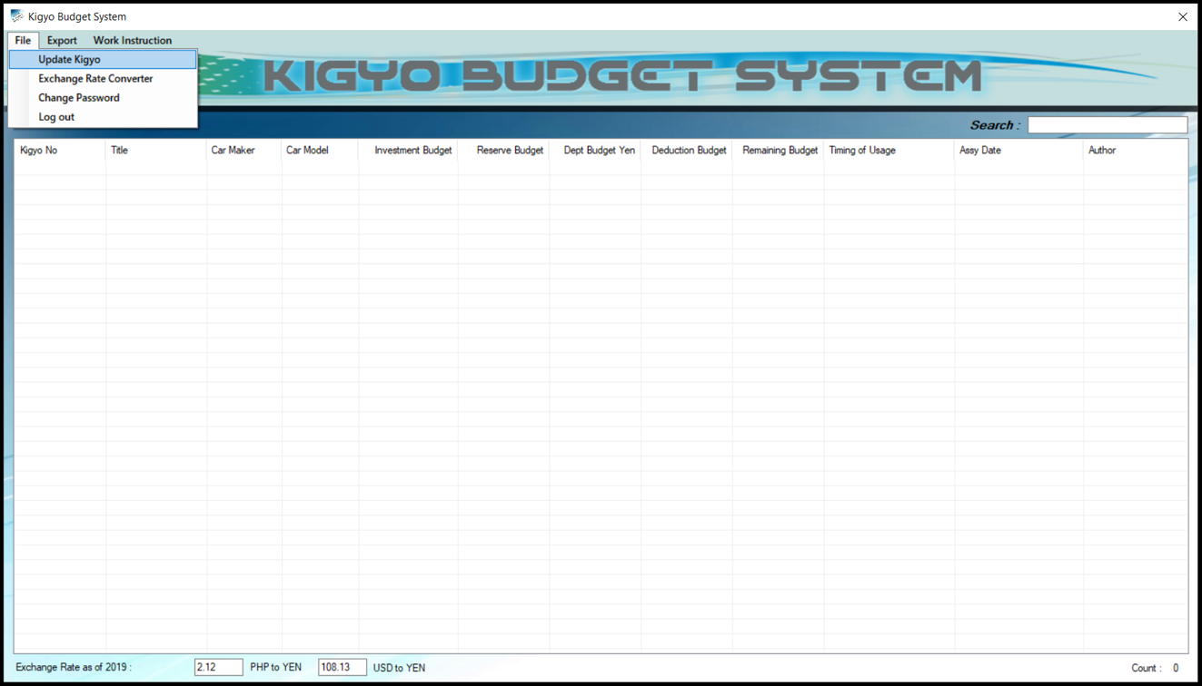

***Figure 1.8***

***One by One Adding Budget***

* 1. Select **Kigyo No.** *(See Figure 1.9).*
  2. Click **Add** button *(See Figure 1.9).*

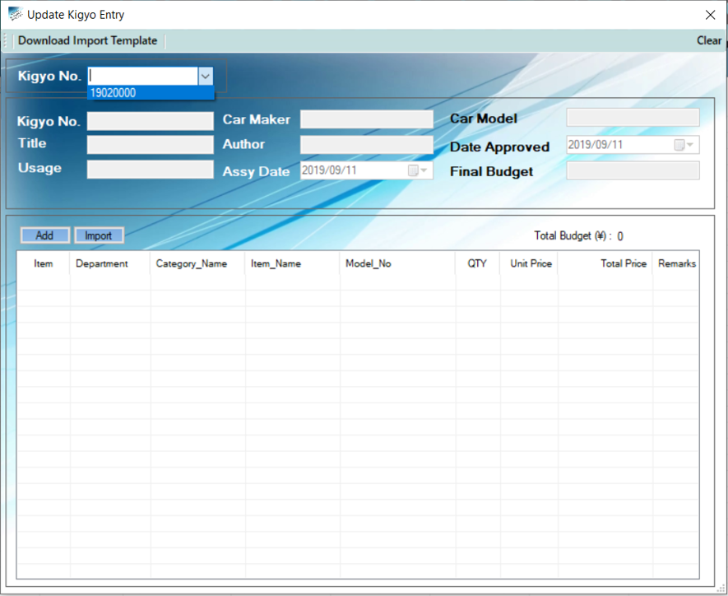

***Figure 1.9***

* 1. Enter **Approved Budget Details** *(See Figure 2.0).*
  2. Click **Add** Button *(See Figure 2.0).*

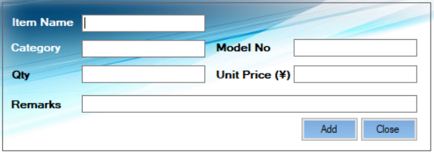

***Figure 2.0***

***Multiple Adding Budget***

* 1. **Download Import Template** *(See Figure 2.1).*
  2. **Browse folder location** and Click **OK** *(See Figure 2.1).*



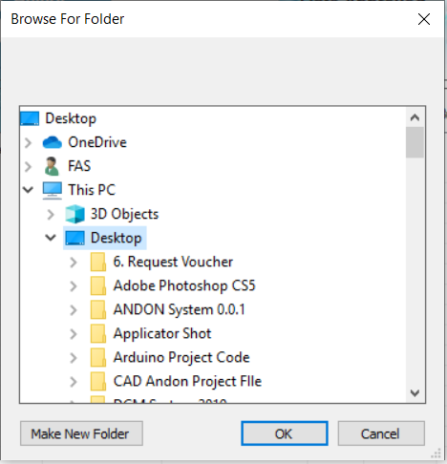

***Figure 2.1***

* 1. Open the **Excel file** and Input **Kigyo Budget Details** *(See Figure 2.2).*

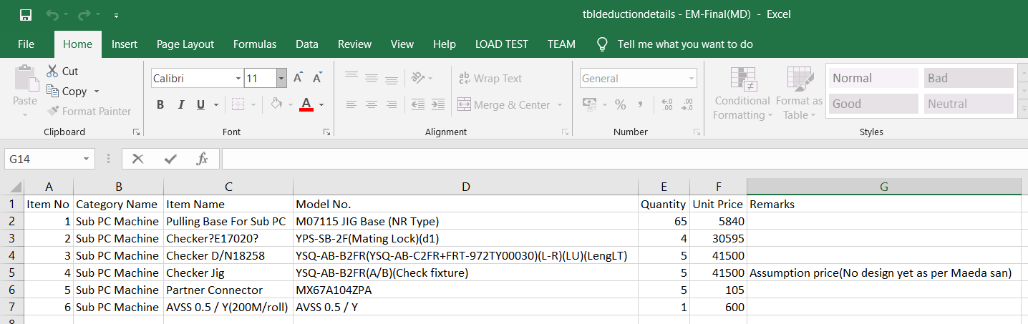

***Figure 2.2***

* 1. Click **Import Button** *(See Figure 2.3).*
  2. Locate the **Excel File** and Click **Open** *(See Figure 2.3).*

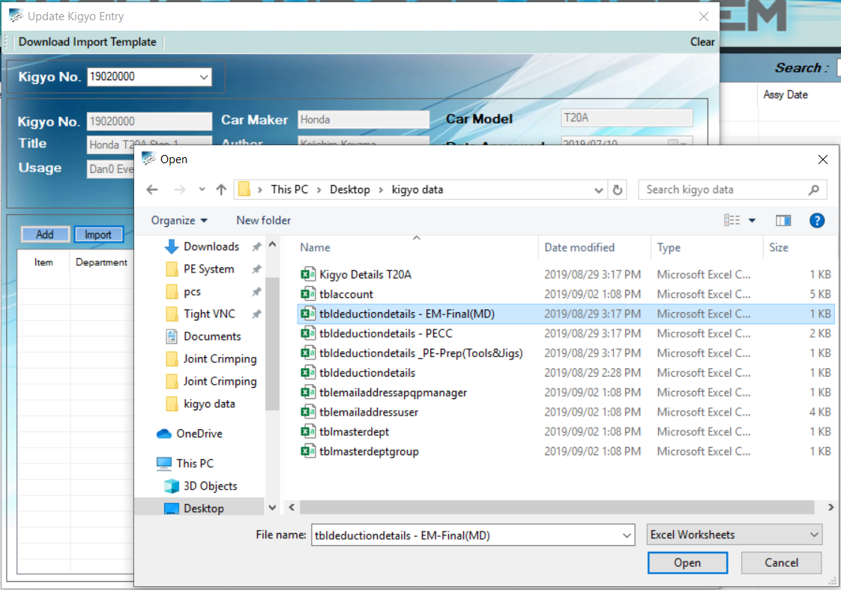

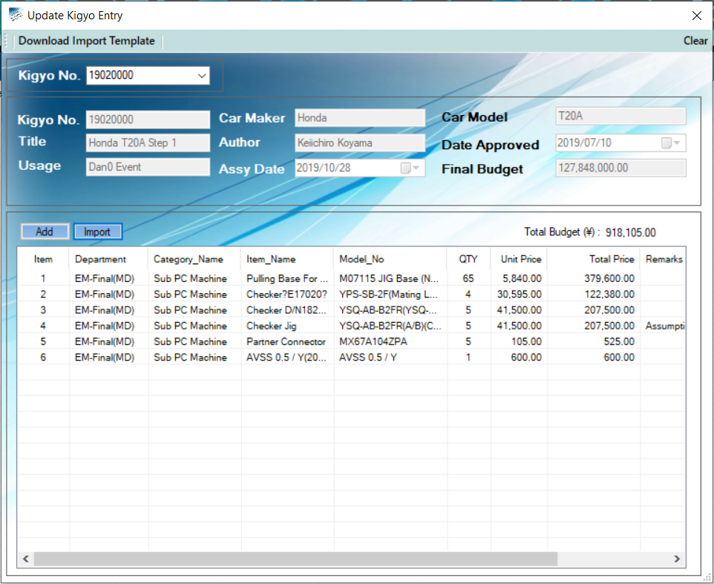 ***Figure 2.3***

***Figure 2.4***

**KIGYO BUDGET SYSTEM**

**Work Instruction**

(**APQP MANAGER:** PE MANAGER)

1. **LOGIN**
2. Enter **Username and Password** *(See Figure 2.5).*
3. Click **Login** Button to access Main Form *(See Figure 2.5).*



***Figure 2.5***

1. **DEDUCTION APPROVAL**
2. Click **FILE** and Select **DEDUCTION APPROVAL** *(See Figure 2.6).*

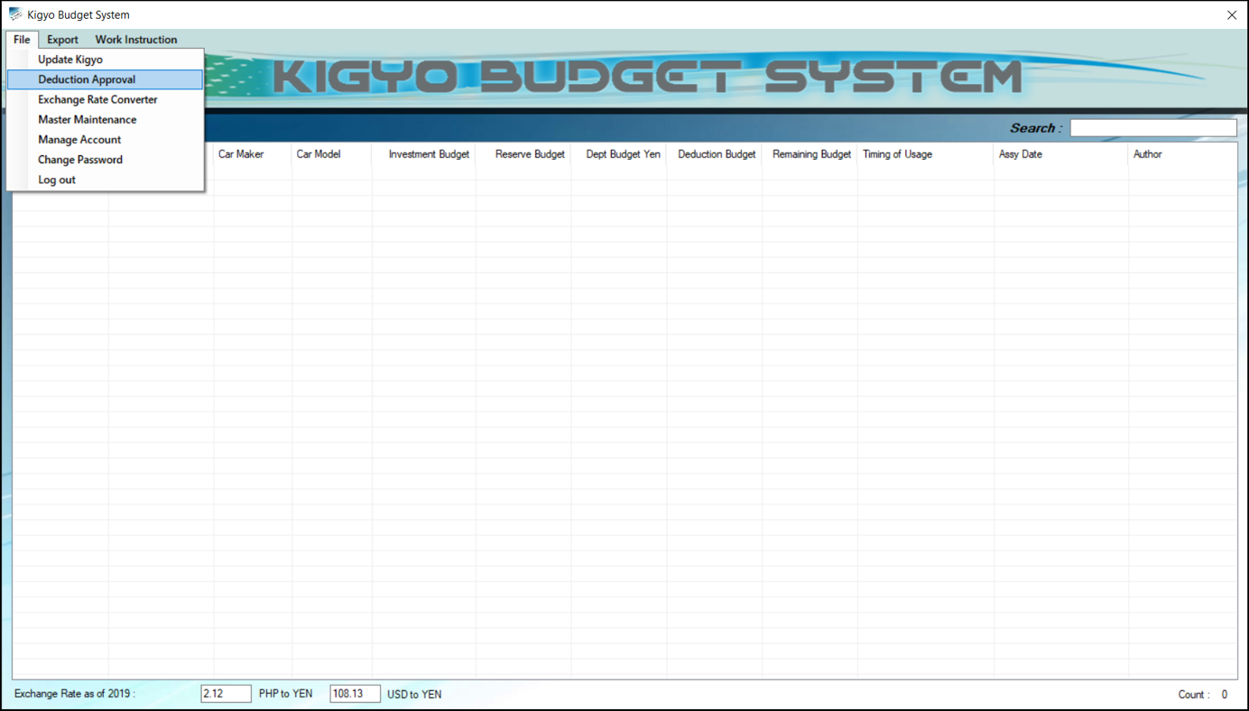

***Figure 2.6***

***One by One Approving Budget***

1. Select **Kigyo No.** and **Dept. Group** *(See Figure 2.7).*
2. Click **Search** Button (*See Figure 2.7).*
3. Right click the **ITEM** and Click **Approved** *(See Figure 2.7).*

***Multiple Approving Budget***

1. Click **Approved** Button (See Figure 2.7).

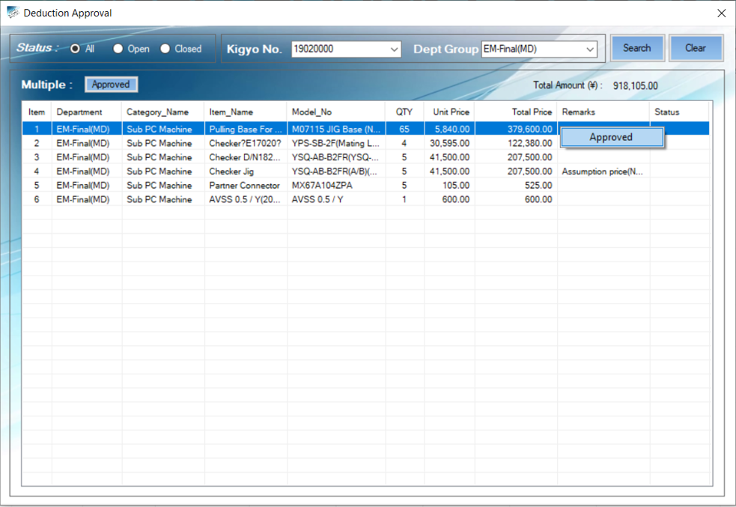

***Figure 2.6***

1. **UPDATE MASTER MAINTENACE**
2. Click **FILE** and Select **MASTER MAINTENANCE** *(See Figure 2.7).*



***Figure 2.7***

1. Select **MASTER MENU** *(See Figure 2.8).*
2. Enter **NEW DATA** and Click **ADD** Button *(See Figure 2.8)*. 

***Figure 2.8***

1. **UPDATE MANAGE ACCOUNT**
2. Click **FILE** and Select **MANAGE ACCOUNT** *(See Figure 2.9).*

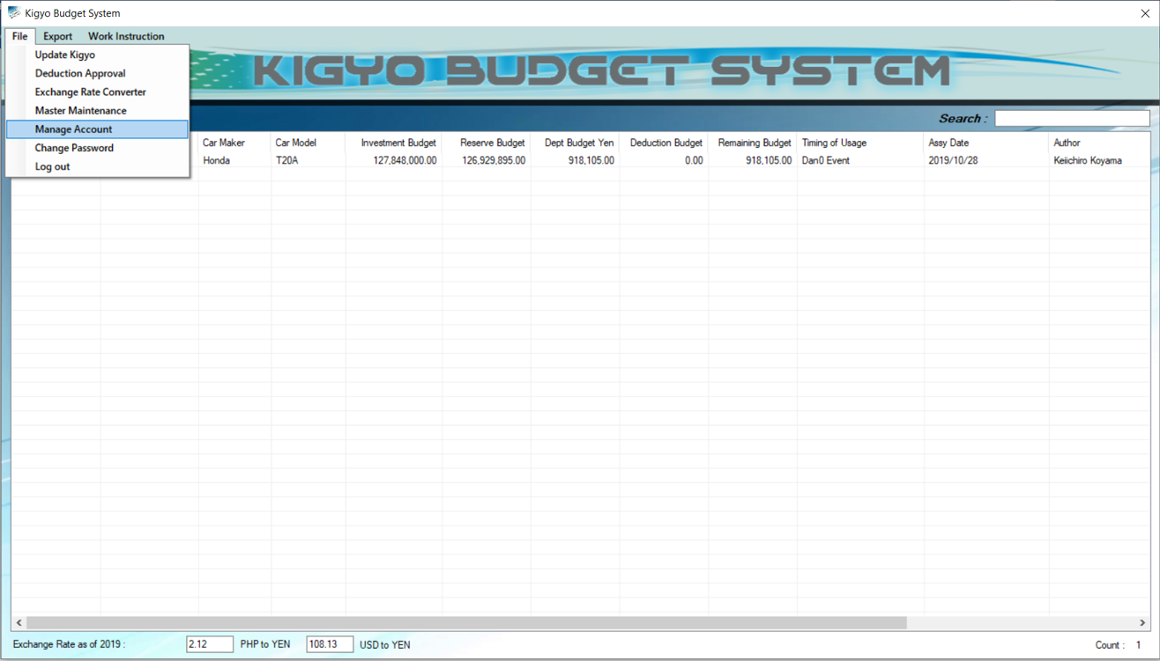

***Figure 2.9***

***Add New User Account***

1. Click **Add New User** *(See Figure 3.0)*.

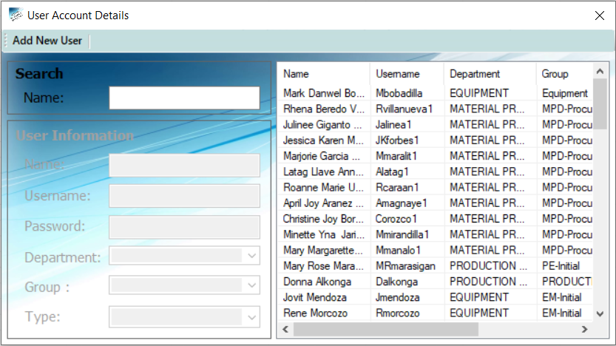

***Figure 3.0***

1. Enter **User Account Information** (*See Figure 3.1)*.
2. Click **Save** button *(See Figure 3.1)*.

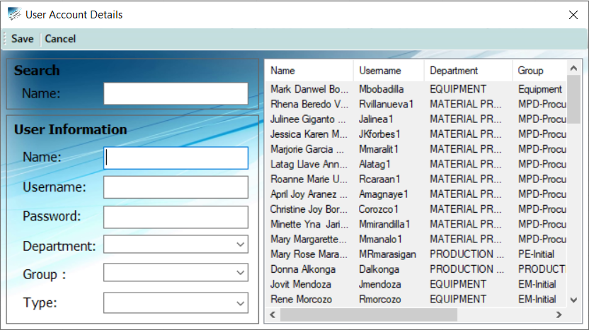

***Figure 3.1***

***Update User Account***

1. Click **Update** button to update the information *(See Figure 3.2)*.

***Delete User Account***

1. Click **Delete** button to permanent delete the record (*See Figure 3.2*).

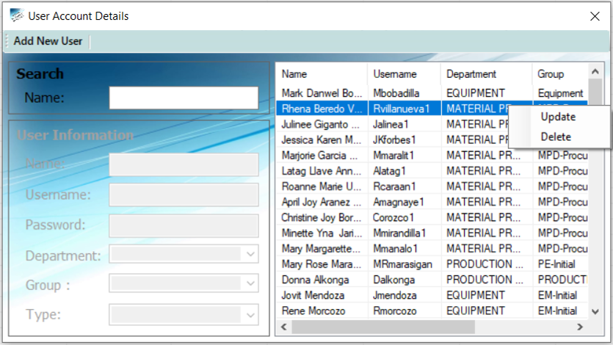

***Figure 3.2***

**KIGYO BUDGET SYSTEM**

**Work Instruction**

(**USER:** PE, QA, EQPT, IT, MP)

1. **LOGIN**
2. Enter **Username and Password** *(See Figure 3.3).*
3. Click **Login** Button to access Main Form *(See Figure 3.3).*



***Figure 3.3***

1. **DEDUCTION BUDGET**

*3.* Right click **Kigyo No. Row** and Select **View Budget Summary** *(See Figure 3.4).*

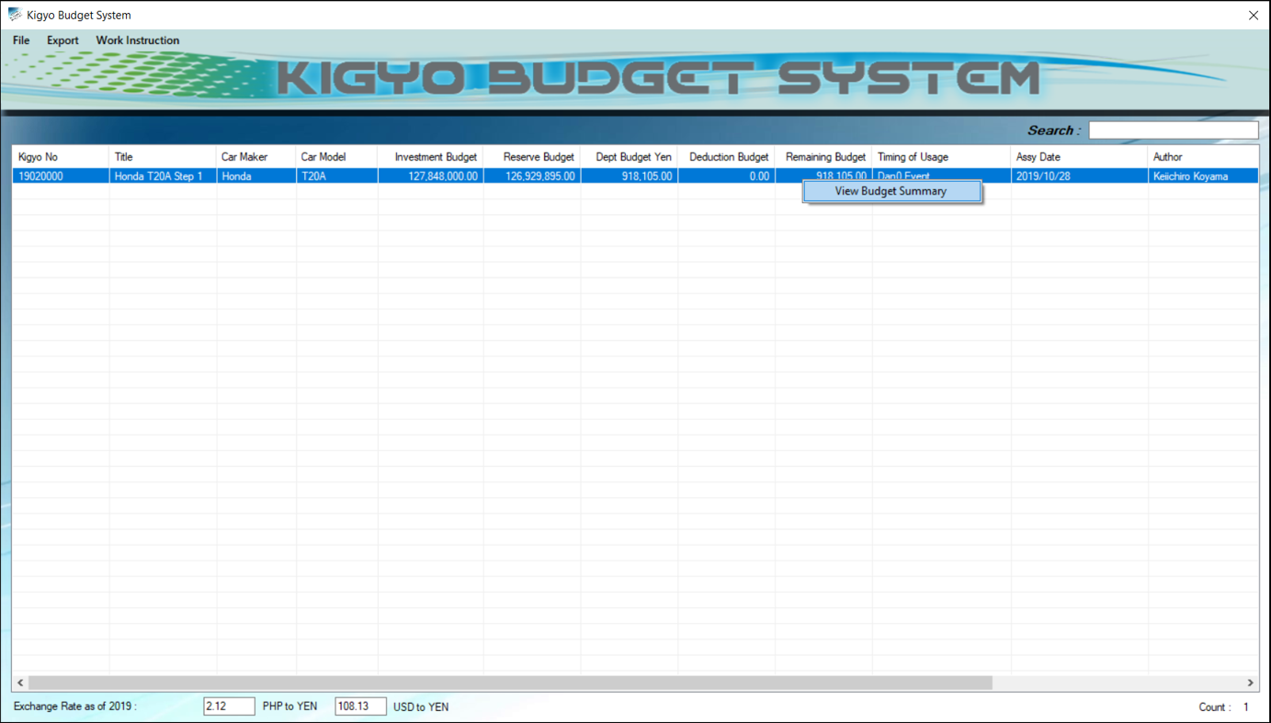

***Figure 3.4***

1. Right click **Dept Group Row** and Select **View Budget Summary** *(See Figure 3.5).*

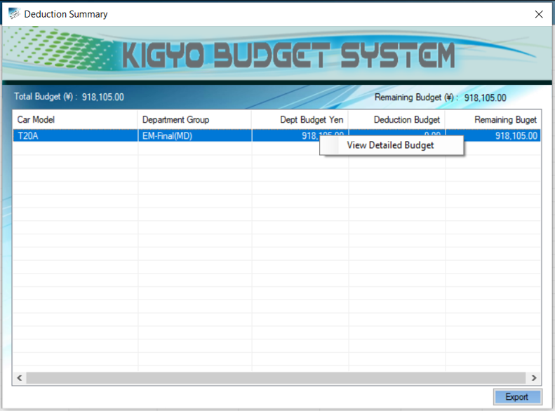

***Figure 3.5***

1. Right click **Item Name Row** and Select **Deduction** *(See Figure 3.6).*

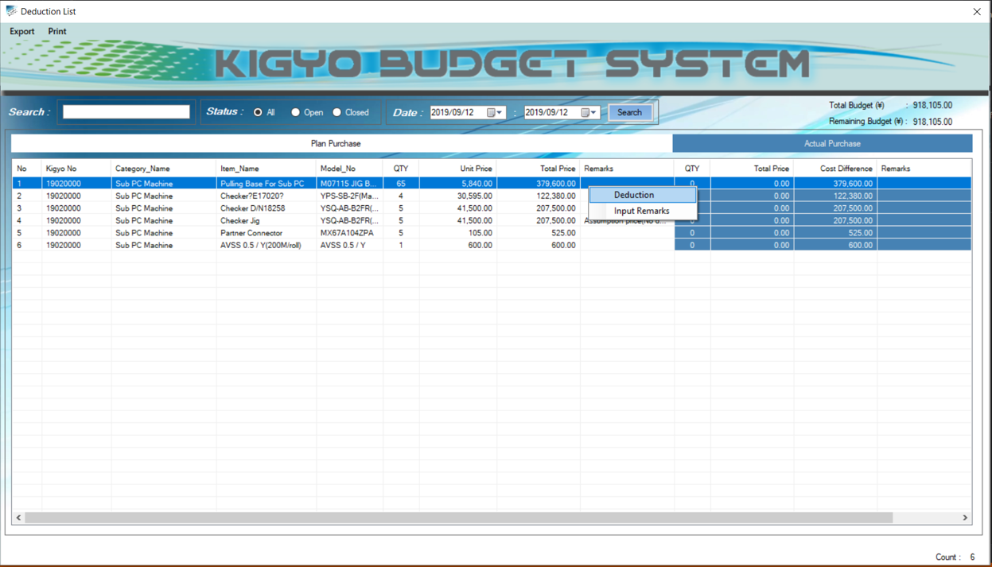

***Figure 3.6***

1. **File** and Select **Add Deduction** *(See Figure 3.7).*

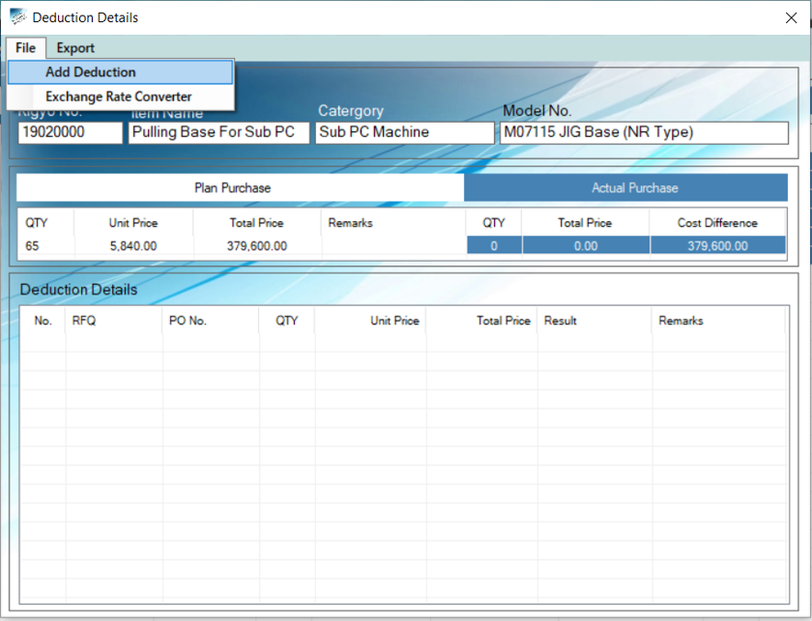

***Figure 3.7***

1. Enter **RFQ No., Qty, Unit Price and Remarks** (*See Figure 3.8).*
2. Click **Add** Button to save the data*(See Figure 3.8).*

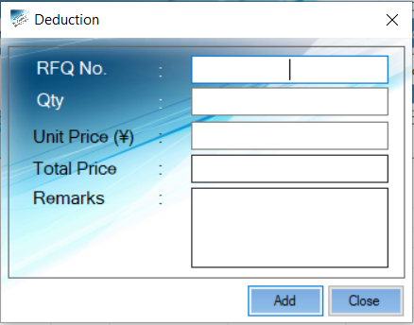

***Figure 3.8***

***Deduction Details Result***

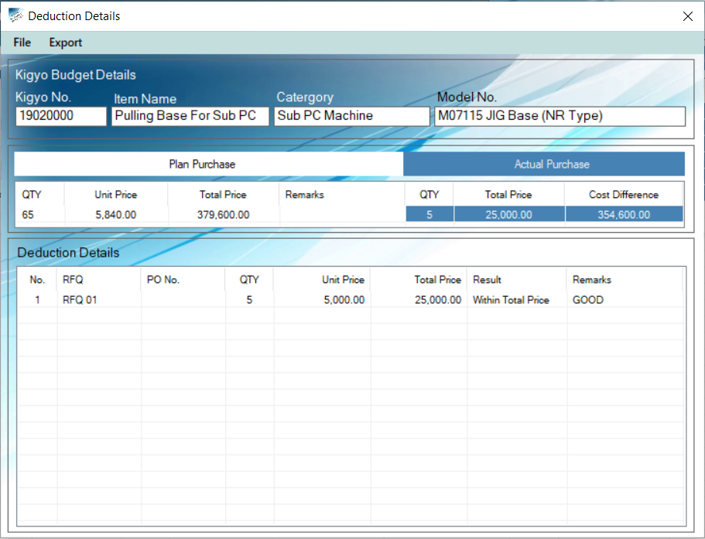

***Figure 3.9***

***Deduction Summary Result***

Highlighted yellow color means deduction is already close*(See Figure 4.0).*

1. To filter **Summary Result** *(See Figure 4.0).*

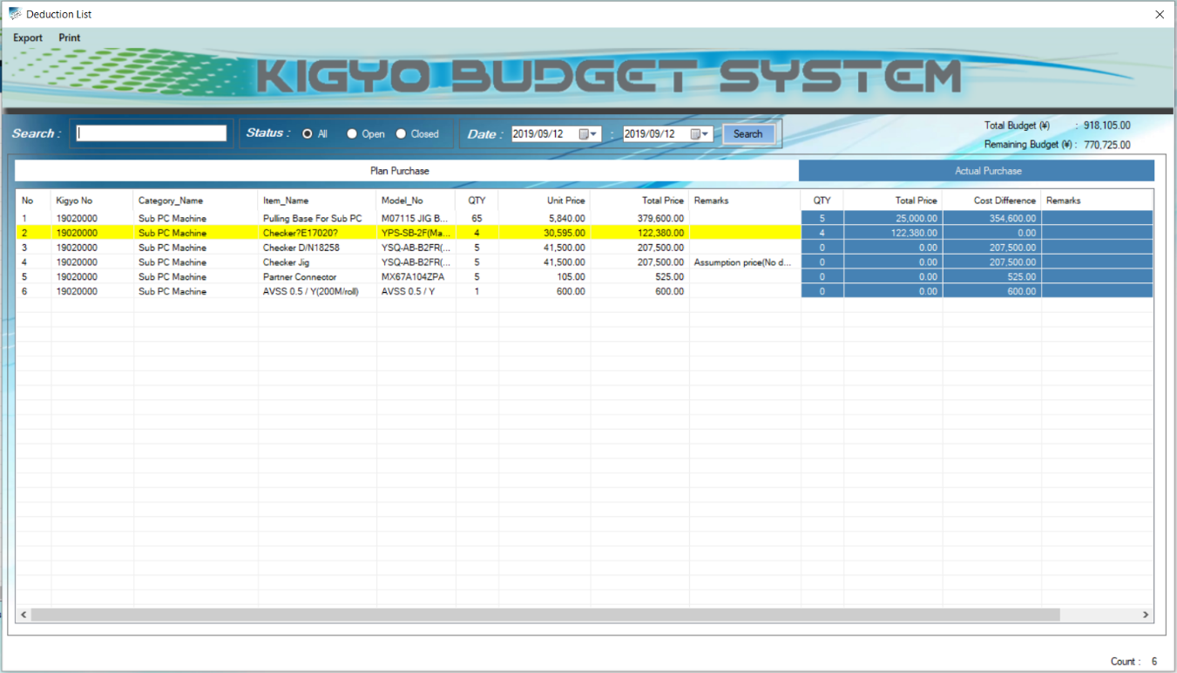

***Figure 4.0***

1. **EXPORT AND PRINT DEDUCTION SUMMARY**
2. Click **Export Excel File** Button *(See Figure 4.1).*
3. 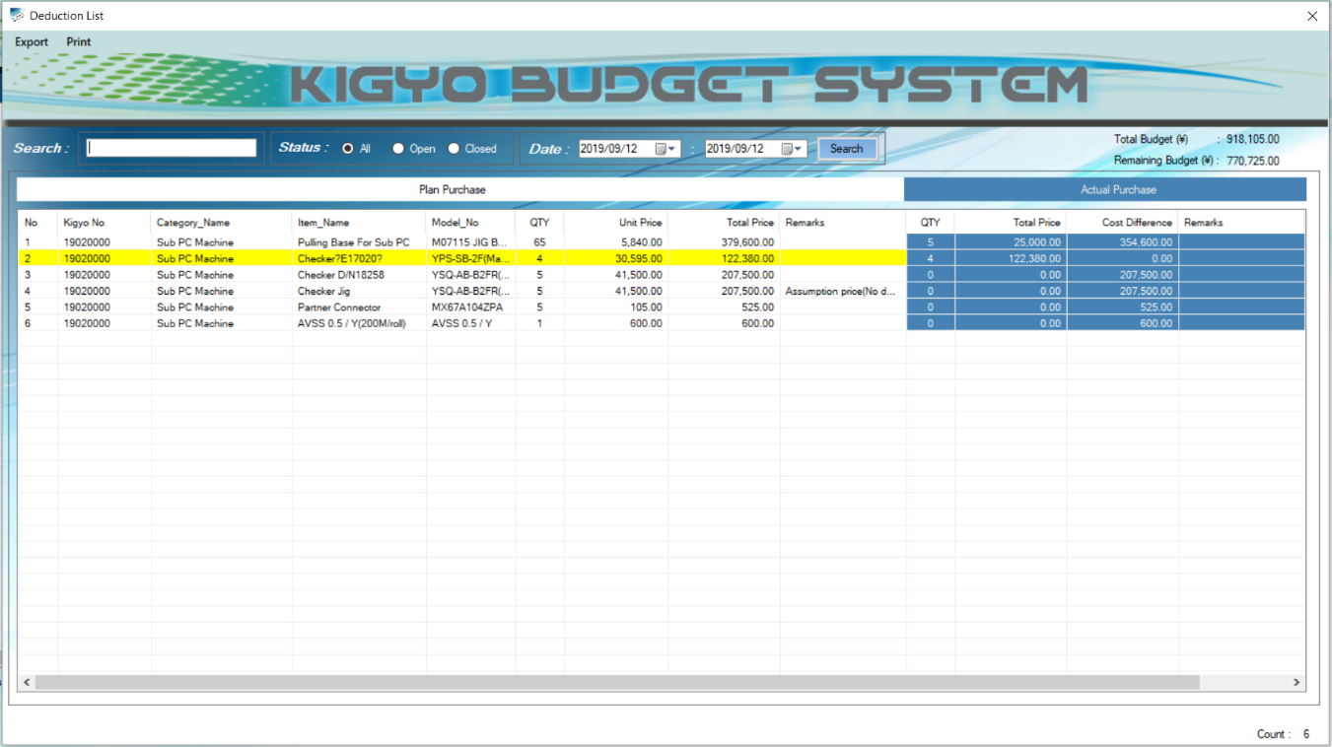Click **Print** Button *(See Figure 4.1).*

***Figure 4.1***

***Export Excel File and Print Result***

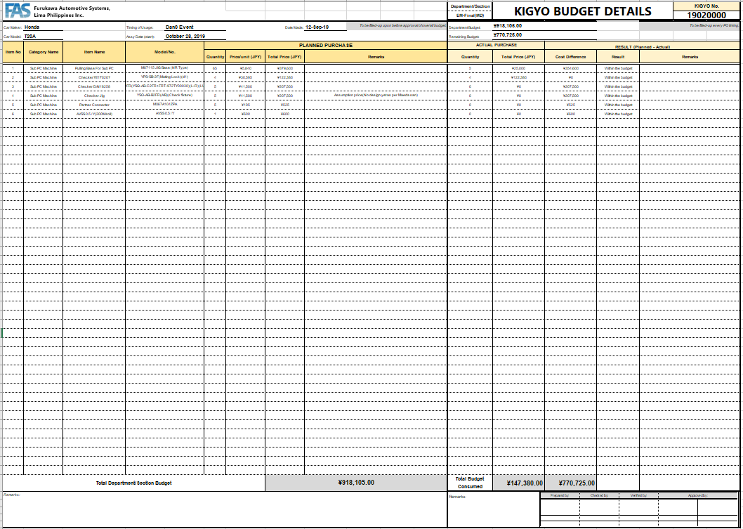

***Figure 4.2***

**KIGYO BUDGET SYSTEM**

**Work Instruction**

(**PROCUREMENT:** MP)

1. **LOGIN**
2. Enter **Username and Password** *(See Figure 4.3).*
3. Click **Login** Button to access Main Form *(See Figure 4.3).*



***Figure 4.3***

1. Click **UPDATE PURCHASE ORDER NO.**
2. **File** and Select **Update Purchase Order No.** *(See Figure 4.4).*

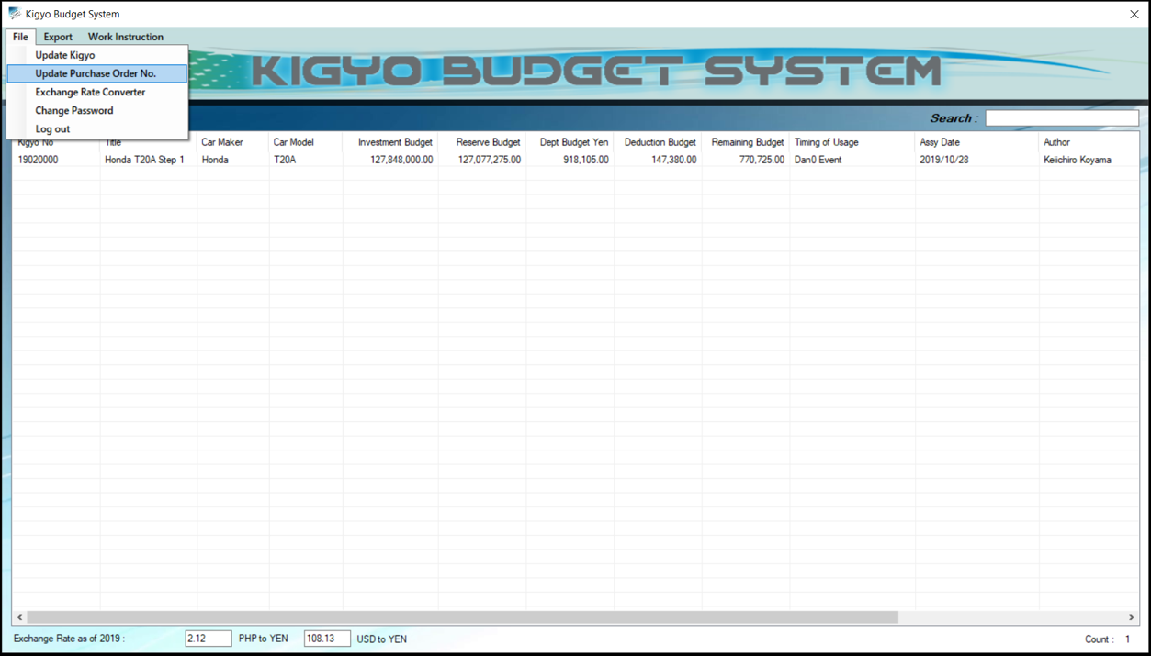

***Figure 4.4***

***One by One Inputting PO. No.***

1. Select **Dept Group** and Enter **RFQ No.** *(See Figure 4.5).*
2. Click **Search** button (*See Figure 4.5).*
3. Right Click **RFQ Row** and Click **Input Purchase Order No.** *(See Figure 4.5).*

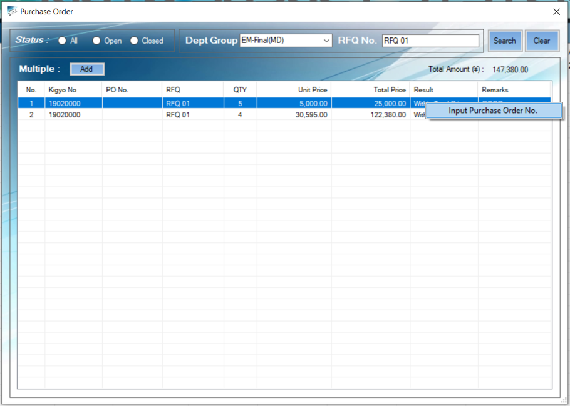

***Figure 4.5***

1. ENTER **PO No.** and Click **OK.** *(See Figure 4.6).*

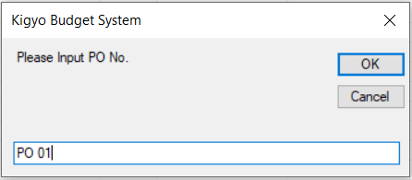

***Figure 4.6***

***Multiple Inputting PO. No.***

1. Select **Dept Group** and Enter **RFQ No.** *(See Figure 4.7).*
2. Click **Search** button *(See Figure 4.7).*
3. Click **Add** button*(See Figure 4.7).*
4. ENTER **PO No.** and Click **OK.** *(See Figure 4.7).*

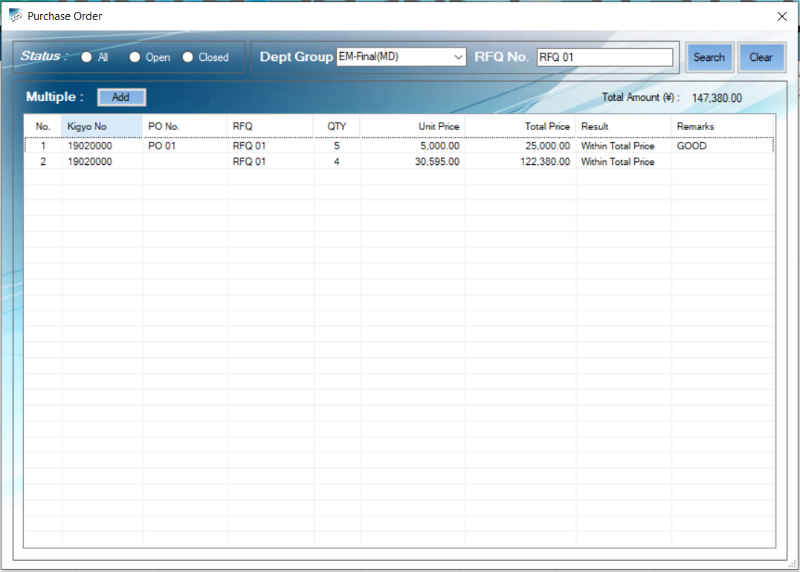

***Figure 4.7***

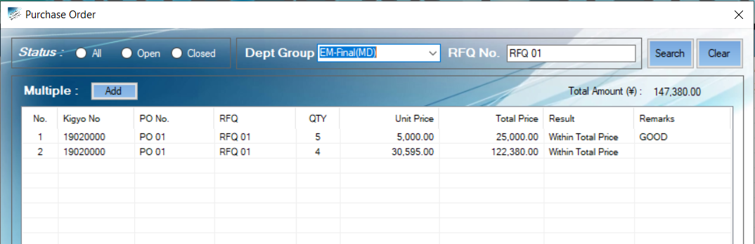***Inputting PO. No Result***

***Figure 4.8***

1. **CANCEL PURCHASE ORDER**
2. Go to **Deduction Details** (*See Figure 4.9).*
3. Right click **Deduction Item** and Click **Delete** button**.** (*See Figure 4.9*).

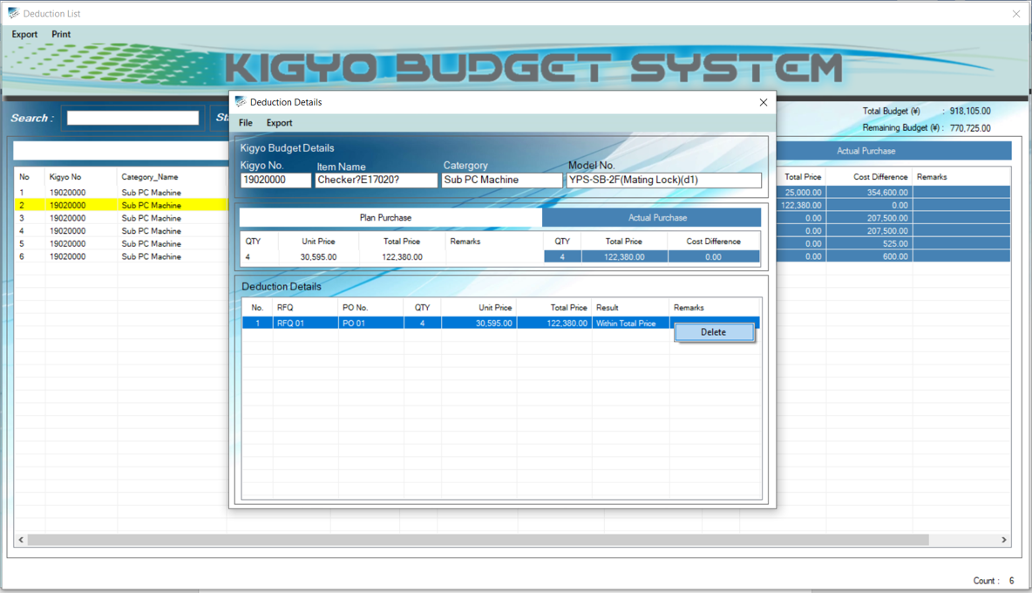

***Figure 4.9***

1. Click **YES** button to cancel the data**.** (*See Figure 5.0*).

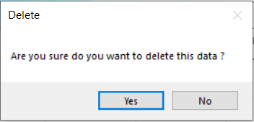

***Figure 5.0***

**KIGYO BUDGET** **SYSTEM**

**Work Instruction**

(**APPROVER:** SECTION MANAGER)

1. **LOGIN**
2. Enter **Username and Password** *(See Figure 5.1).*
3. Click **Login** Button to access Main Form *(See Figure 5.1).*



***Figure 5.1***

1. **CANCEL PURCHASE ORDER**

*3.* Right click **Kigyo No. Row** and Select **View Budget Summary** *(See Figure 5.2).*



***Figure 5.2***

*4.* Right click **Dept Group Row** and Select **View Budget Summary** *(See Figure 5.3).*



***Figure 5.3***

*5*. Right click **Item Name Row** and Select **Deduction** *(See Figure 5.4).*

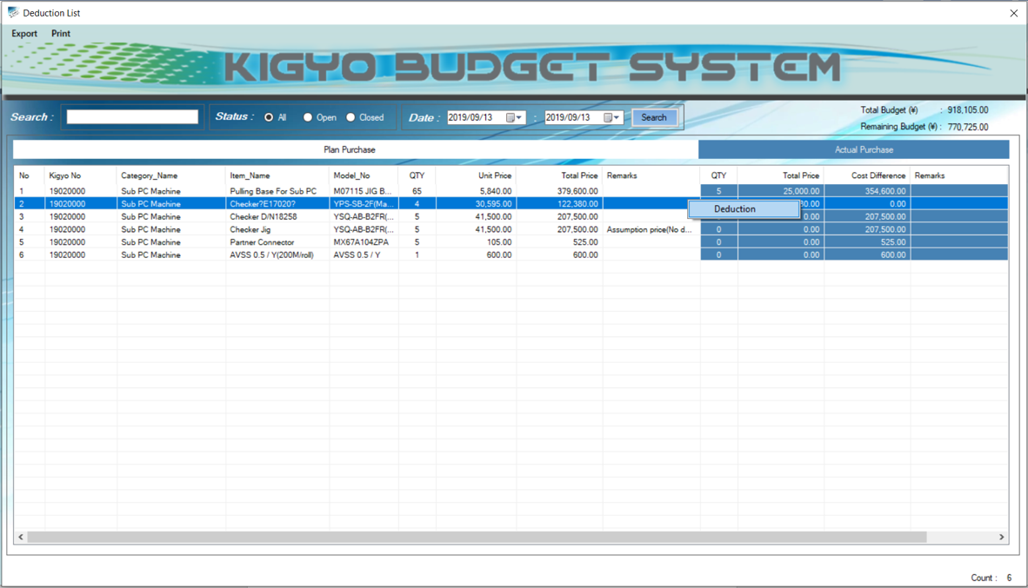

***Figure 5.4***

*6*. Right click **Deduction Item** and Click **Delete** button**.** (*See Figure 5.4*).



***Figure 5.4***

1. Click **YES** button**.** (*See Figure 5.5*).



***Figure 5.5***